# Data sources

OHLCV

* 1. Yfin
  2. <https://labs.ig.com/>
  3. <https://docs.cdp.coinbase.com/cdp-sdk/docs/welcome>

# Features:

1. User can see what is the most recent downloaded data and can confirm what time frame and ticker has data available for.
   1. Also need to understand the start date and end date of that data available
   2. And when was it last updated
   3. And the source of that data (yfin)
2. User can easily select a ticker and time frame that is already available in the backend
   1. Timeframe must have:
      1. 1m, 5m, 15m, 30m, 1h, 4h
      2. 1d, 1w, 1M
3. User can define parameters for the backtest that include a uniqueID such as Name
   1. Other parameters user can define for the backtest:
      1. Strategy name
      2. Description
      3. Ticker,
      4. timeframe,
      5. Spread
      6. Commissions
      7. Capital
      8. Position size
4. User can define custom Entry signal and Exit signals that can be based on
   1. Indicator parameters being at a specific level
   2. Stop Loss or take profit as a percent or price value
   3. For eg:

| **Open Long** | **Close Long** | **Open Short** | **Close Short** |
| --- | --- | --- | --- |
| price < low BB && RSI < 25 | price > highBB && RSI?75 | price > highBB && RSI?75 | price < low BB && RSI < 25 |
| RSI>75 && highBB | +/- 5% take profit or Stop | RSI<75 && ADX>30 && BB are wide | +/- 5% take profit or Stop |
| MACD crossover < 0 && BB wide | +/- 5% take profit or Stop | crossover >0 && BB wide | +/- 5% take profit or Stop |
| price>200MA&& RSI>50 | +/- 5% take profit or Stop | price<200MA&& RSI<50 | +/- 5% take profit or Stop |

1. When user run backtest the results must be shown in a readable format and stores in SQL or CSV
   1. USer must be able to see the following metrics and calc of all trades, long trades only and short trades only

| **Metric** | **All trades** | **Long** | **Short** |
| --- | --- | --- | --- |
| Total Net Profit |  |  |  |
| Gross Profit |  |  |  |
| Gross Loss |  |  |  |
| Profit Factor |  |  |  |
|  |  |  |  |
| Total No of Trades |  |  |  |
| Percent Profitable |  |  |  |
| Winning Trades |  |  |  |
| Losing Trades |  |  |  |
| Even Trades | (after cost no profit) |  |  |
|  |  |  |  |
| Avg Trade Net Profit |  |  |  |
| Avg Winning Trade |  |  |  |
| Avg Losing Trade |  |  |  |
| Ratio Avg win:Avg Loss |  |  |  |
| Largest Winning Trade |  |  |  |
| Largest Losing Trade |  |  |  |
| Max Consecutive Winning Trades |  |  |  |
| Max Consecutive Losing Trades |  |  |  |
| Avg bars in Winning |  |  |  |
| Avg bars in Losing |  |  |  |
| Avg bars in even |  |  |  |
| Max shares/Contracts held |  |  |  |
| Total shares/Contracts held |  |  |  |
| Account size Required |  |  |  |
| Return on initial Capital |  |  |  |
| Annual rate of return |  |  |  |
| Return retracement Ratio |  |  |  |
| RINA index |  |  |  |
| Trading Period |  |  |  |
| Percent of Time in Market |  |  |  |
| Max Equity Run up |  |  |  |
| **Max Drawdown (intraday peak to valley)#** |  |  |  |
| Value |  |  |  |
| Net profits as % of Drawdown |  |  |  |
| **Max Drawdown (Trade Close to Trade Close)** |  |  |  |
| Value |  |  |  |
| Net profits as % of Drawdown |  |  |  |
|  |  |  |  |
| Expectancy | avgwinners*win% +avg losers*lose % / -avg losers |  |  |
| Slippage |  |  |  |
| Commision |  |  |  |

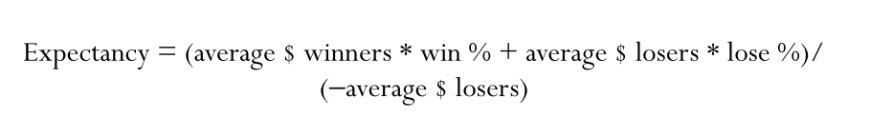

1. User can see all backtest ina table format either in SQL/CSV where they can compare key metrics such as
   1. Total net profit
   2. Max Drawdown
   3. Total trades
   4. % of winning trades
   5. Profit factor